SQLite insert

Working but not recommended way of inserting

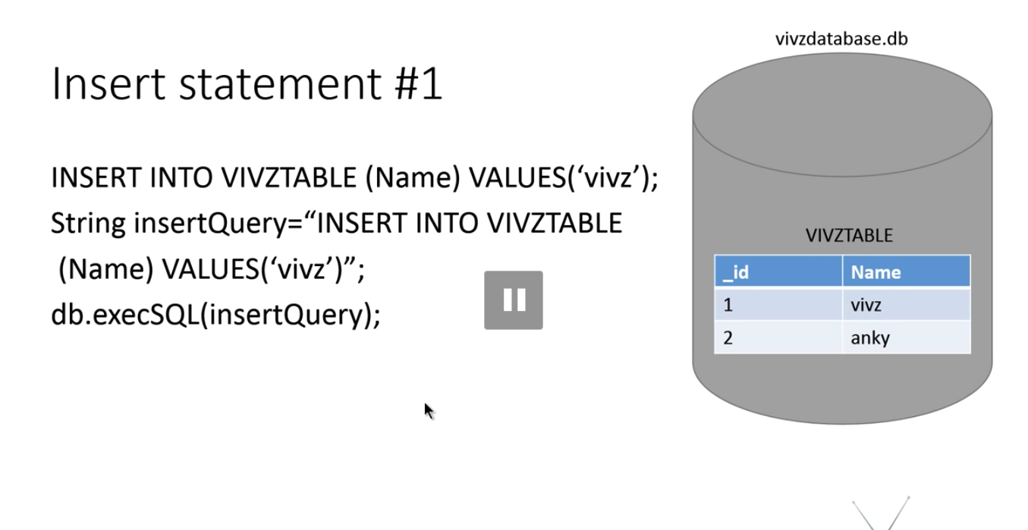

Android way of inserting things

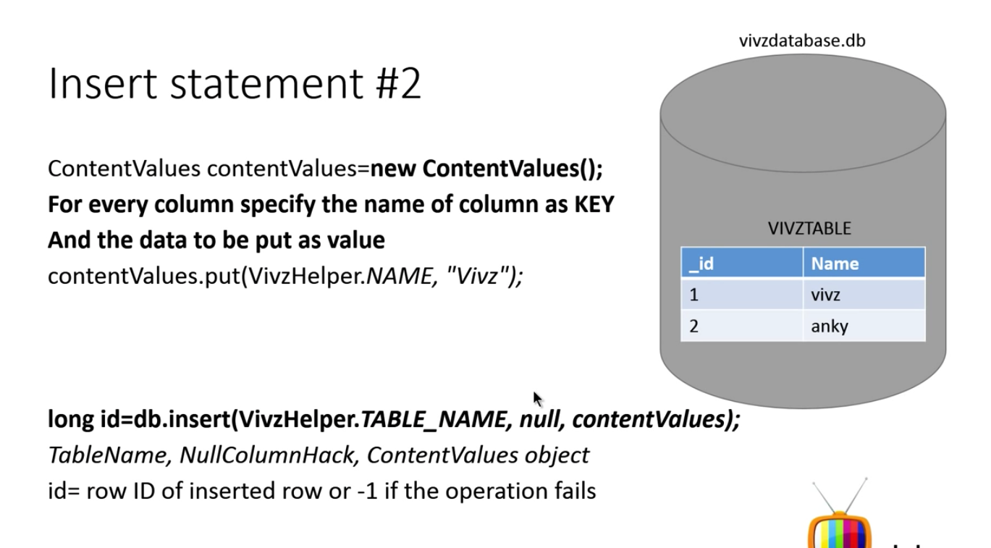

What is nullColumnHack

Android doesn’t allow you to insert null (empty row) into the table. If you want to do that, you have to specify that column to nullColumnHack parameter

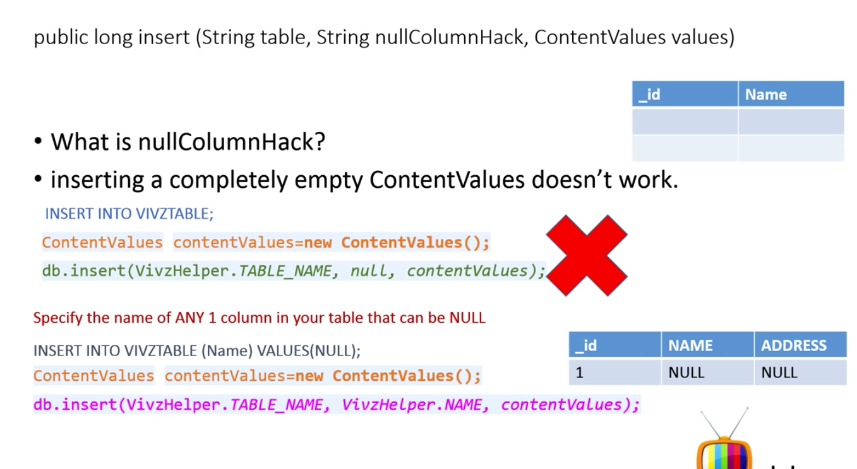

What is the Best way to insert data?

